DATA ANALYTICS PRACTICAL REPORT

1. Introduction
This report documents the practical implementation of setting up a data analytics environment using Anaconda, Jupyter Notebook, Google Colab, essential Python libraries, and GitHub. The objective was to establish a working Python environment and perform basic analytics tasks.

2. Installation of Anaconda and Python Verification
Python and Conda versions were verified using the command prompt.

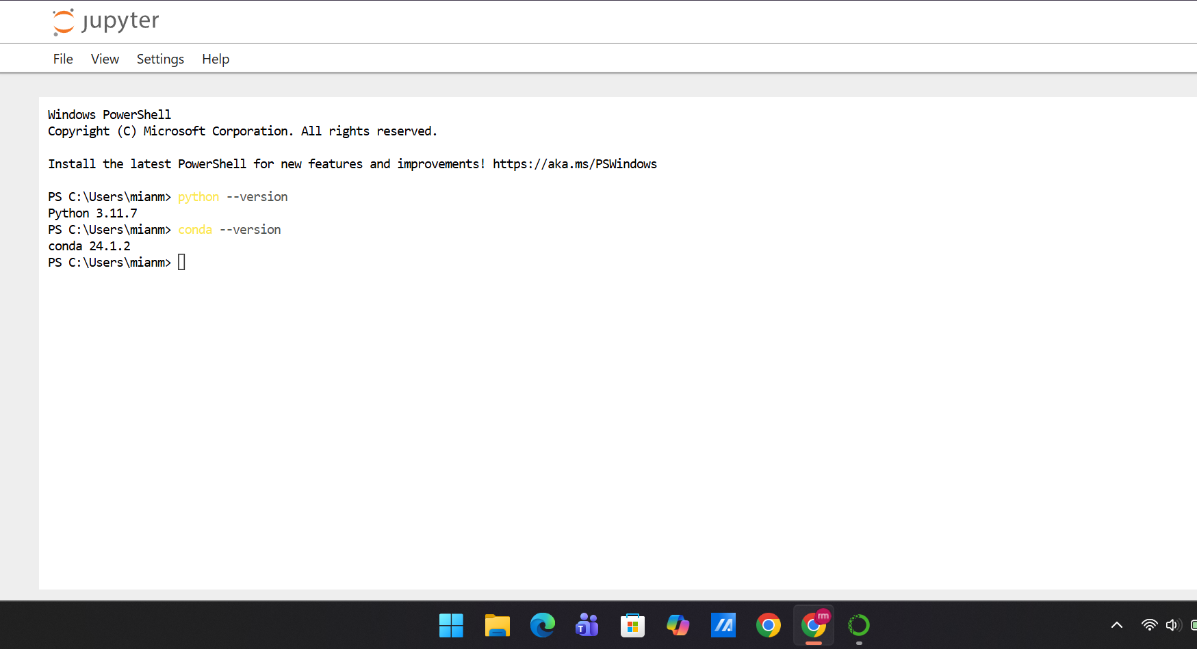3. Jupyter Notebook Setup
Jupyter Notebook was launched successfully using the command 'jupyter notebook'.

4. Google Colab Setup
Google Colab was accessed online and a new notebook was created.

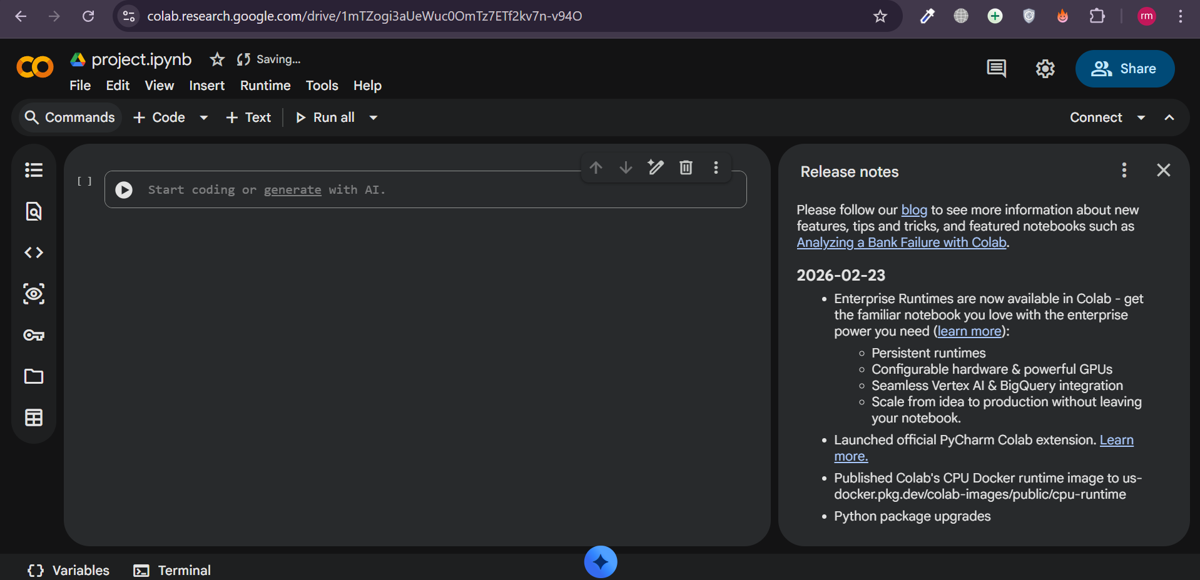5. Installation of Essential Libraries
The following libraries were installed and verified:
- pandas
- NumPy
- matplotlib
- seaborn

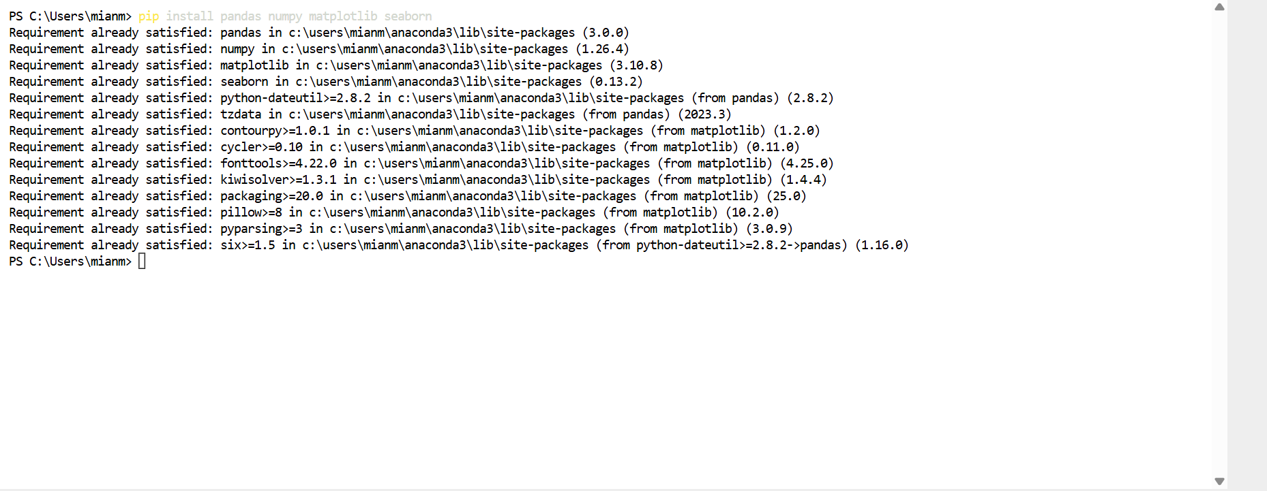6. First Jupyter Notebook – Basic Python Operations
Basic arithmetic operations and list functions were executed successfully.

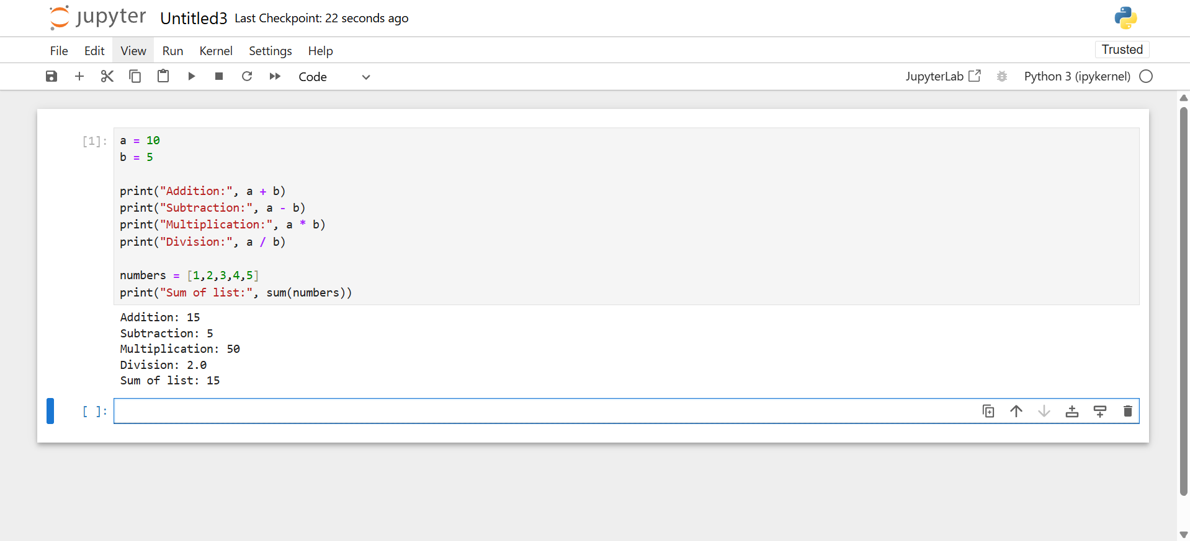7. Data Visualization Example
A simple line graph was created using matplotlib.

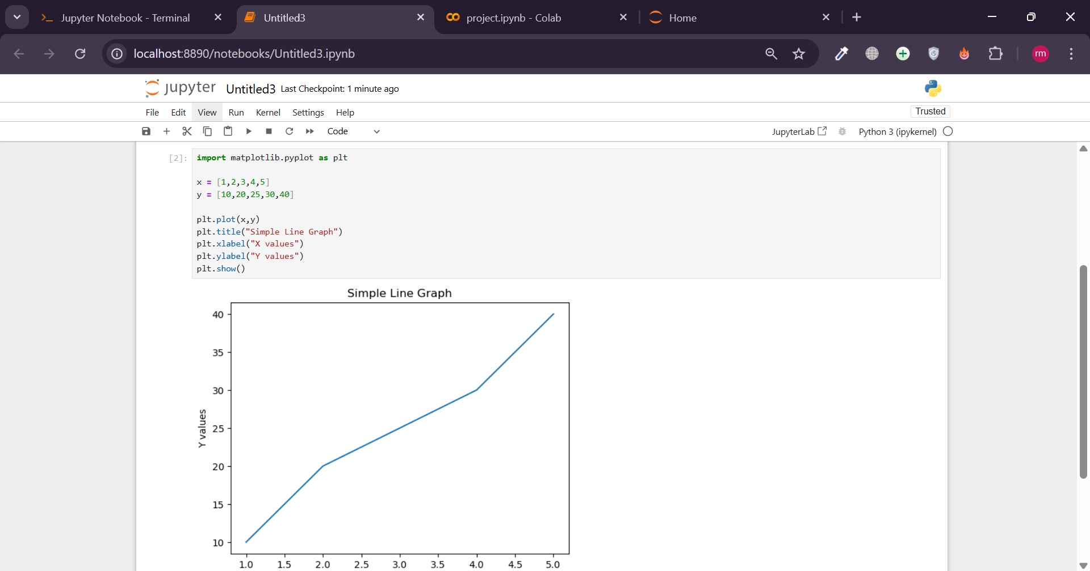8. Data Analytics Use Cases Across Industries
Healthcare – Disease prediction, patient data analysis.
Banking & Finance – Fraud detection, credit risk analysis.
E-Commerce – Customer behavior analysis, sales forecasting.
Education – Student performance tracking.
Transportation – Traffic prediction and route optimization.

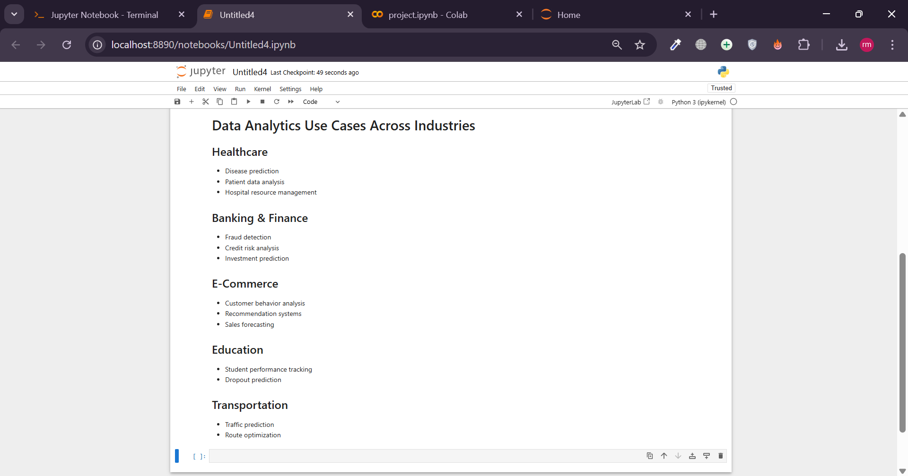9. GitHub Repository Creation
A GitHub repository was created and the notebook was uploaded successfully.

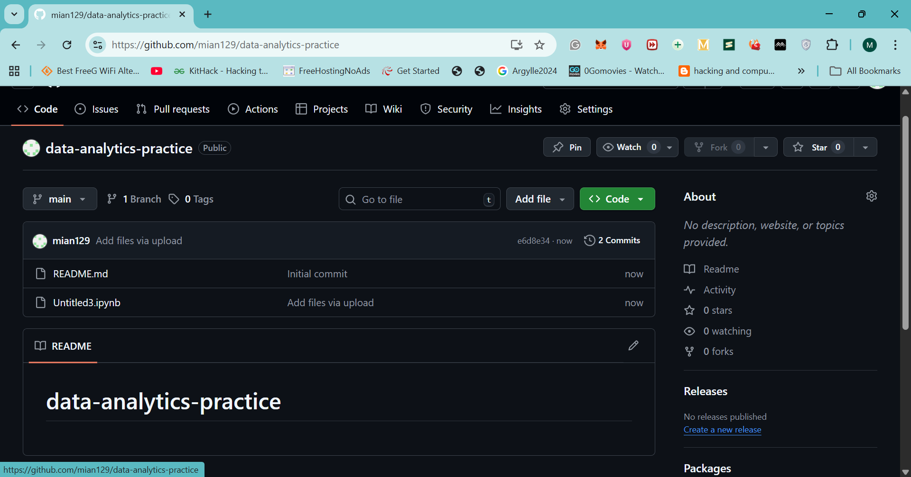10. Conclusion
This practical task successfully demonstrated the setup of a complete Python data analytics environment. The tools were installed, verified, and tested with basic operations and visualization.

